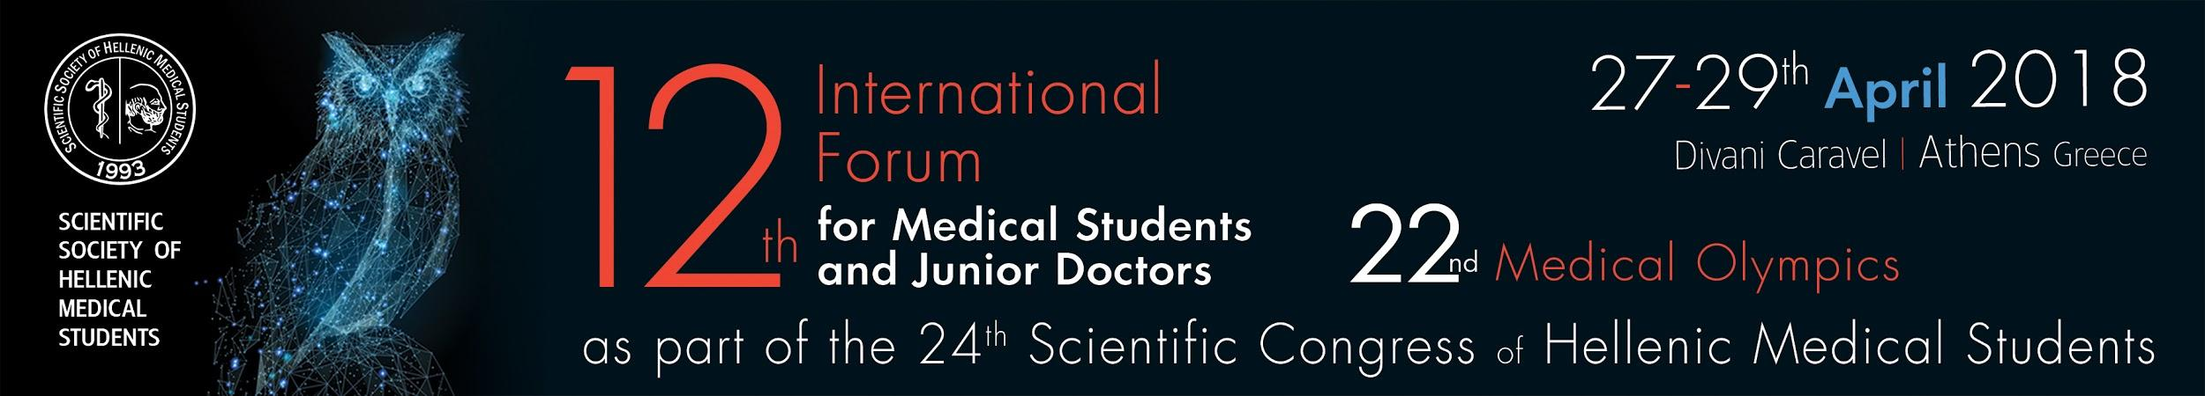

**24th Scientific Congress of Hellenic Medical Students & 12th International Forum for Medical Students and Junior Doctors**

**The Annual Medical Student and Junior Doctor Event**

The Scientific Congress of Hellenic Medical Students (SCHMS) is organized this year by the Athens Chapter of the Scientific Society of Hellenic Medical Students (SSHMS). The conference is the most important activity of the SSHMS serving as a forum for students from all medical schools in the country, as well as students from non-medical or para-medical studies. Several distinguished international scientists and faculty from all the Greek Universities participate, mentoring the event. The objective of the organizers is to provide an opportunity to students from various disciplines and institutions who are interested in medical science to interact and network. This year the event takes place in the capital of Greece, Athens. Foreign medical students will have the opportunity to actively take part in the conference at the 12th International Forum for Medical Students and Junior Doctors. At the 12th International Forum for Medical Students and Junior Doctors, renowned physicians from Greece or abroad will give topical presentations in prevalent areas of medical research. The Forum also includes 10 hands-on workshops and a variety of specifically designed seminars on open issues and challenges of modern medicine. <http://24esfie.gr/en/brief-program-2/> | <http://24esfie.gr/en/workshops-2/>

SCHMS is an annual event recognized internationally and is conducted under the auspices of the Seven National Medical Schools of the country. It includes:

1. Round table presentations, open paper sessions and e-posters in a wide variety of topics, from students supervised by distinguished medical school professors <http://24esfie.gr/en/topics/>
2. Project Award Competitions for abstracts that were submitted to the congress:

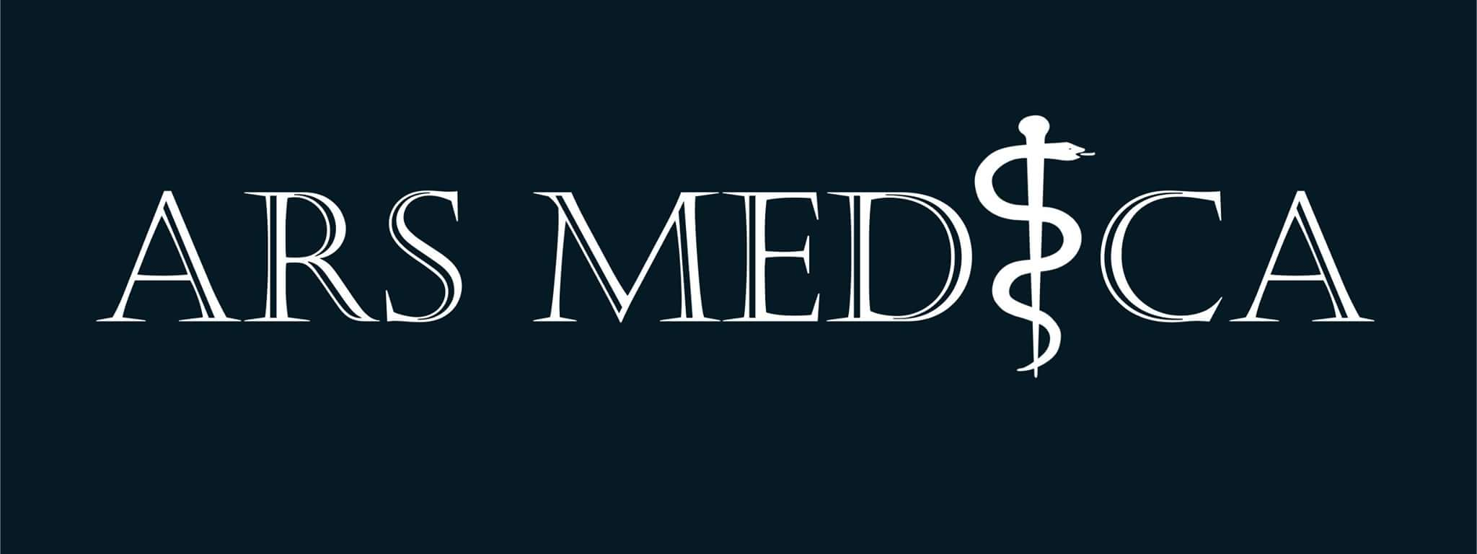

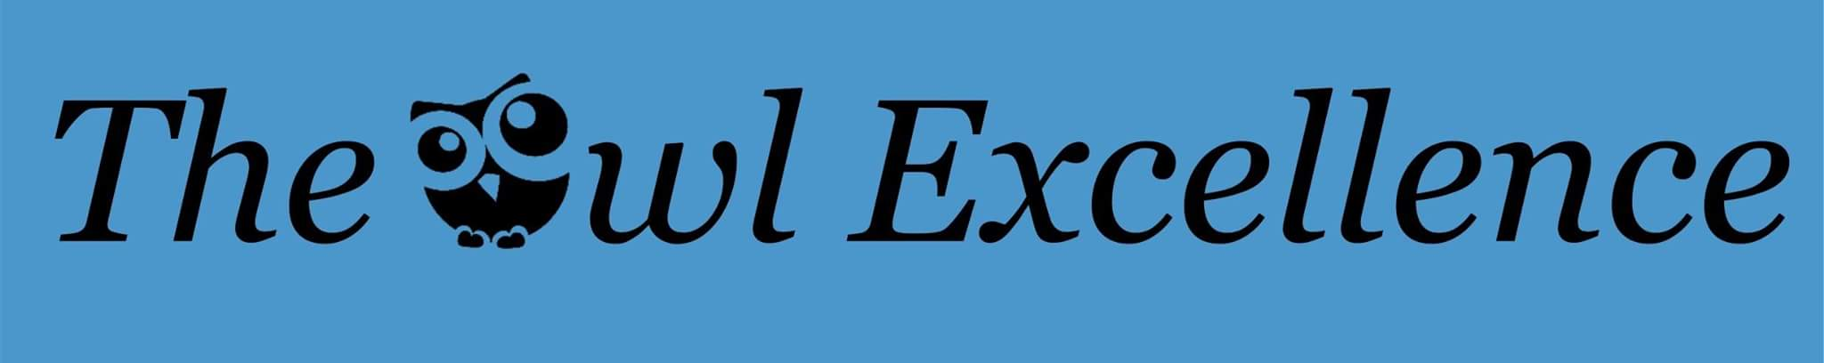

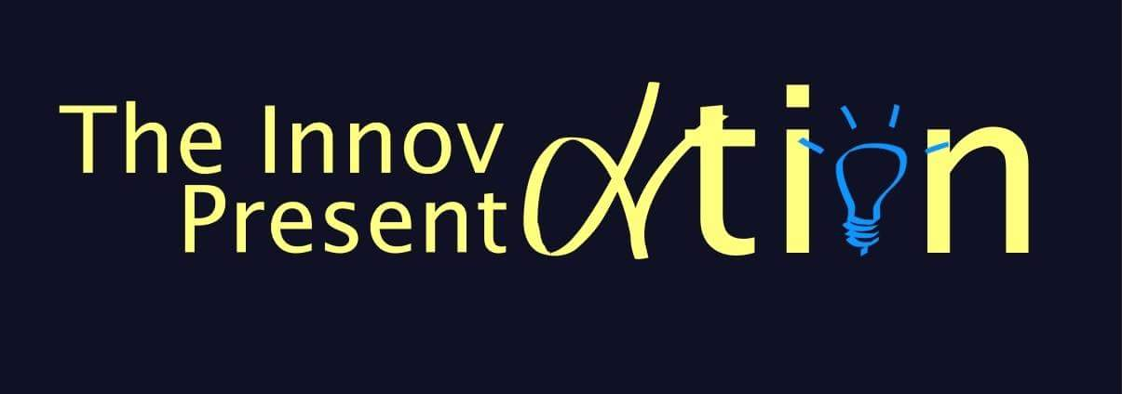

1. The 22nd Medical Olympics, a competition on the medical body of knowledge, open to medical students of every year of study. <http://24esfie.gr/en/medical-olympics/>

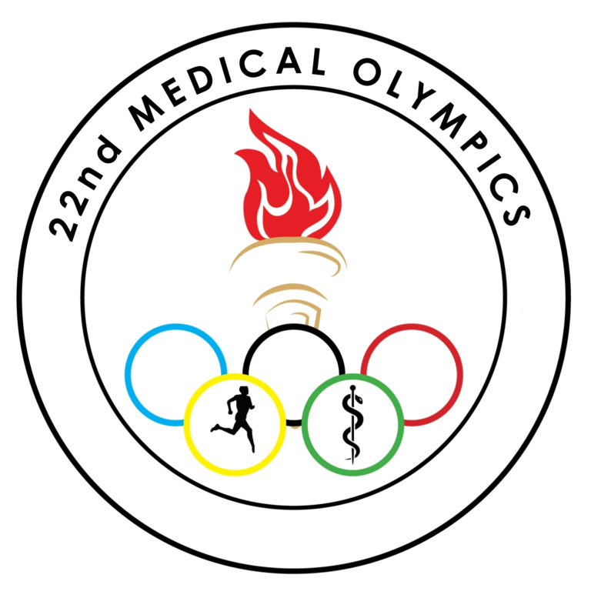

1. The Da Vinci Xi robotic surgery simulator which will be available for on-site practice. Participants will also have the opportunity to watch robotic surgery live, and to take part in surgery competition.
2. Keynote speaker Dr. Konstantine A. Stratakis, director of NIH. Dr. Stratakis is well known for his research concerning tumors of adrenal glands. He contributed to the discovery of the Carney-Stratakis Syndrom.

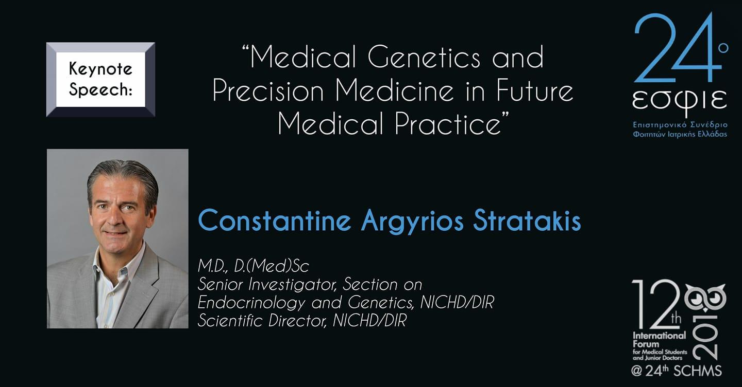

SCHMS is the only nationwide scientific conference in Greece that has lasted through the years, and is organized by students for students. Participation offers experience in paper presentation, development of organizational skills, opportunities to network, connecting with foreign medical students, intra-institutional cooperation and rewards, getting access to state-of-the art information on innovative research and its products, and a chance to meet distinguished professors-mentors.

Promoting multidisciplinarity, the 24th SCHMS has partnered with Student Teams of other Health Sciences Groups of the Greek Universities:

* Athens Dental Student Association (National and Kapodistrian University of Athens)
* Dental Students Organization (Aristotle University of Thessaloniki)
* Greek Pharmaceuticals Student Federation (National and Kapodistrian University of Athens)
* Bioscientific Team University of Patras (University of Patras)
* IEEE NTUA Student Branch (National and Technical University of Athens)

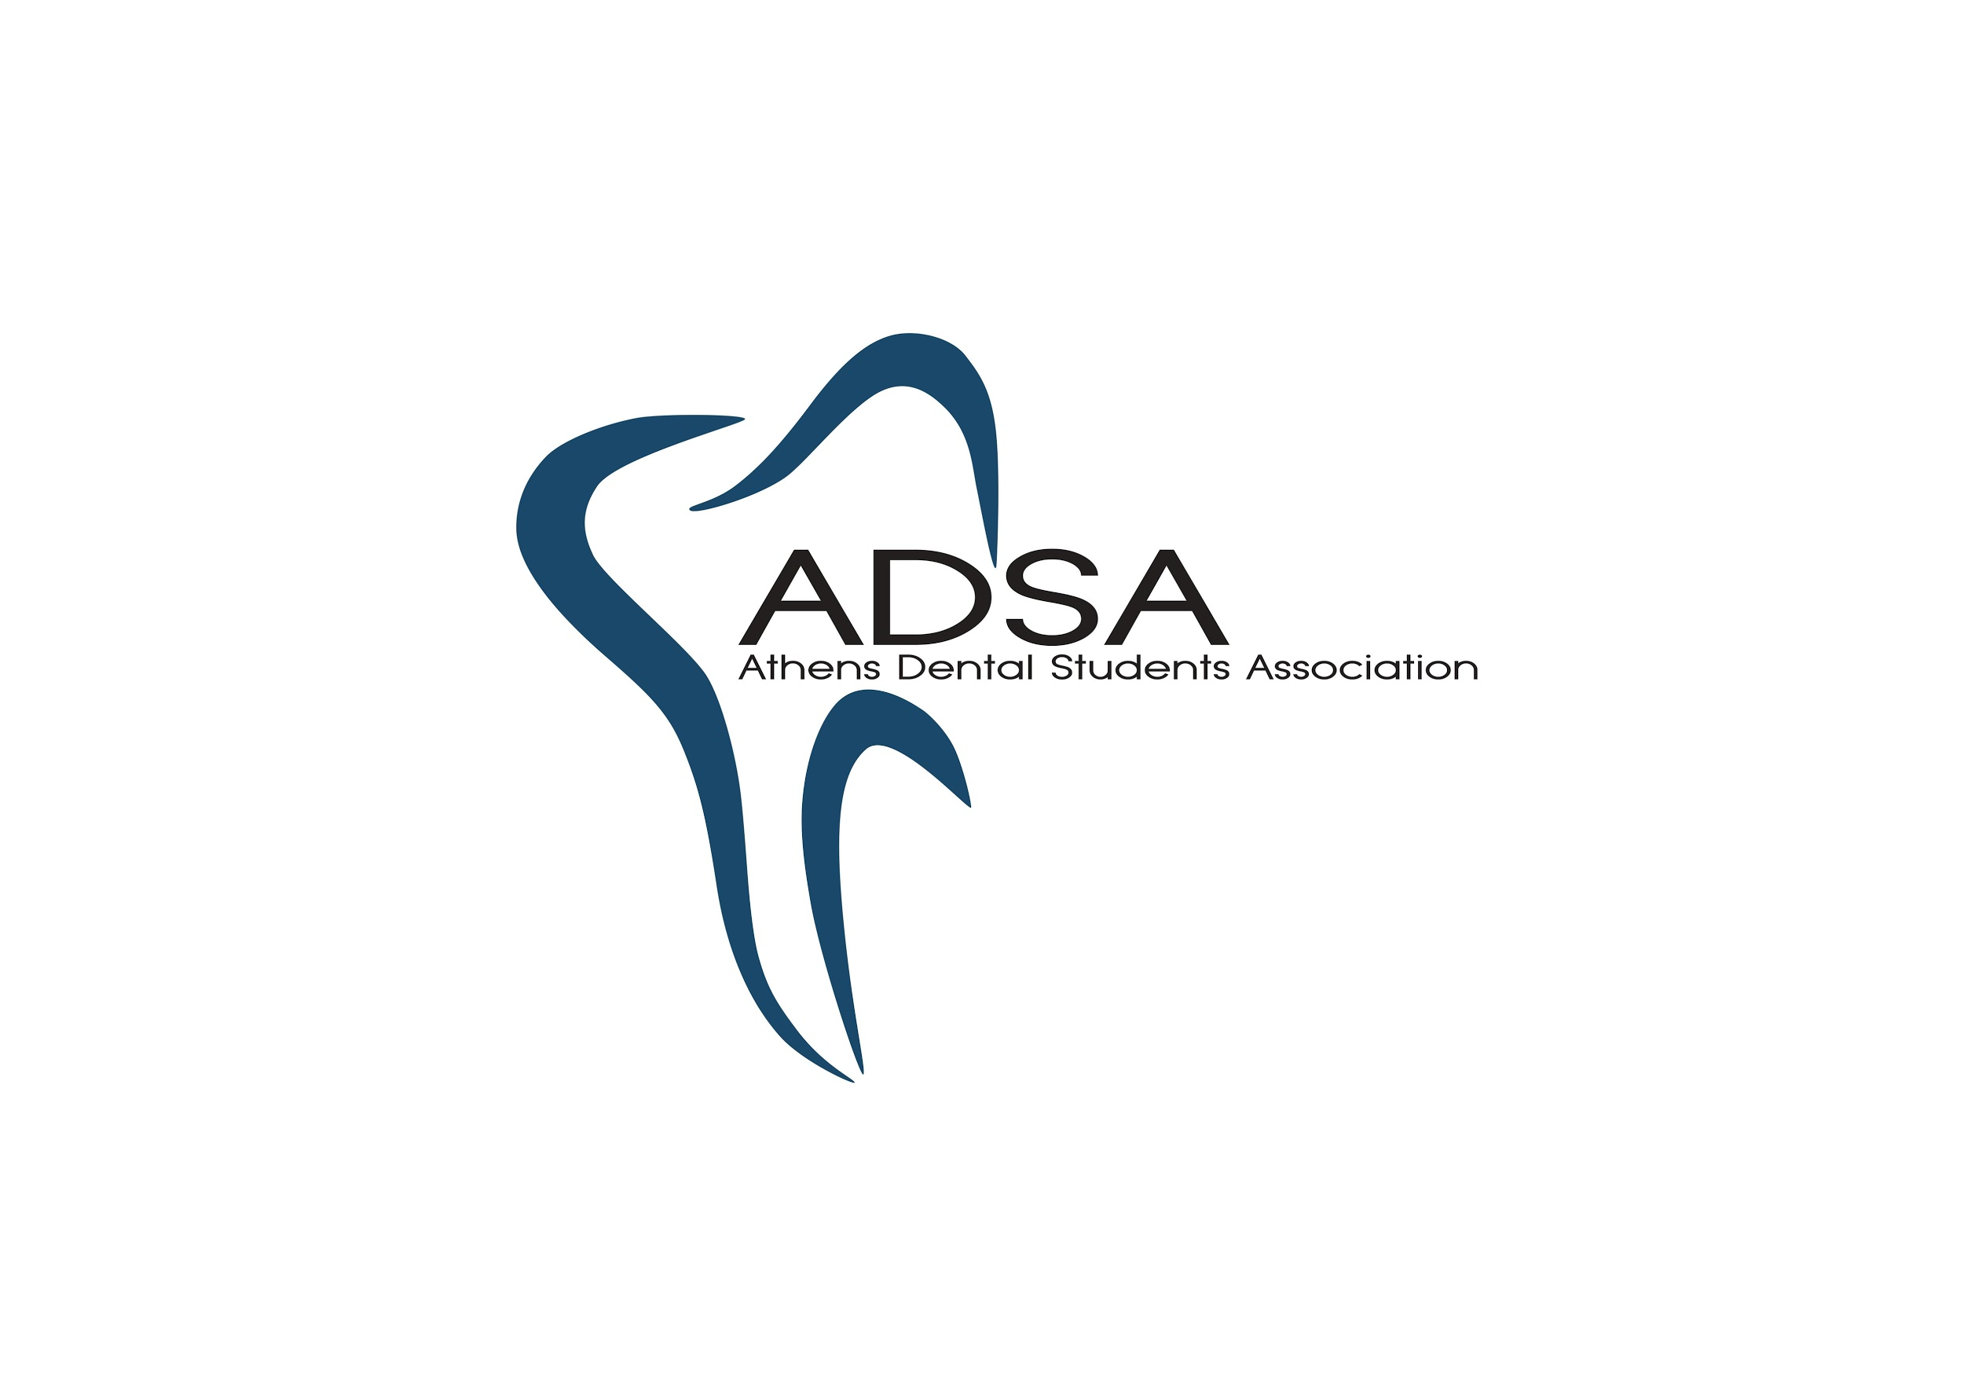 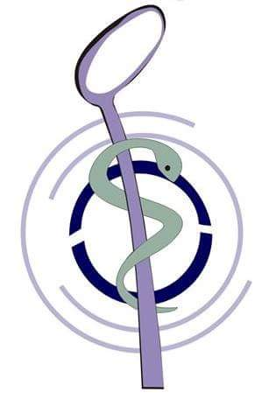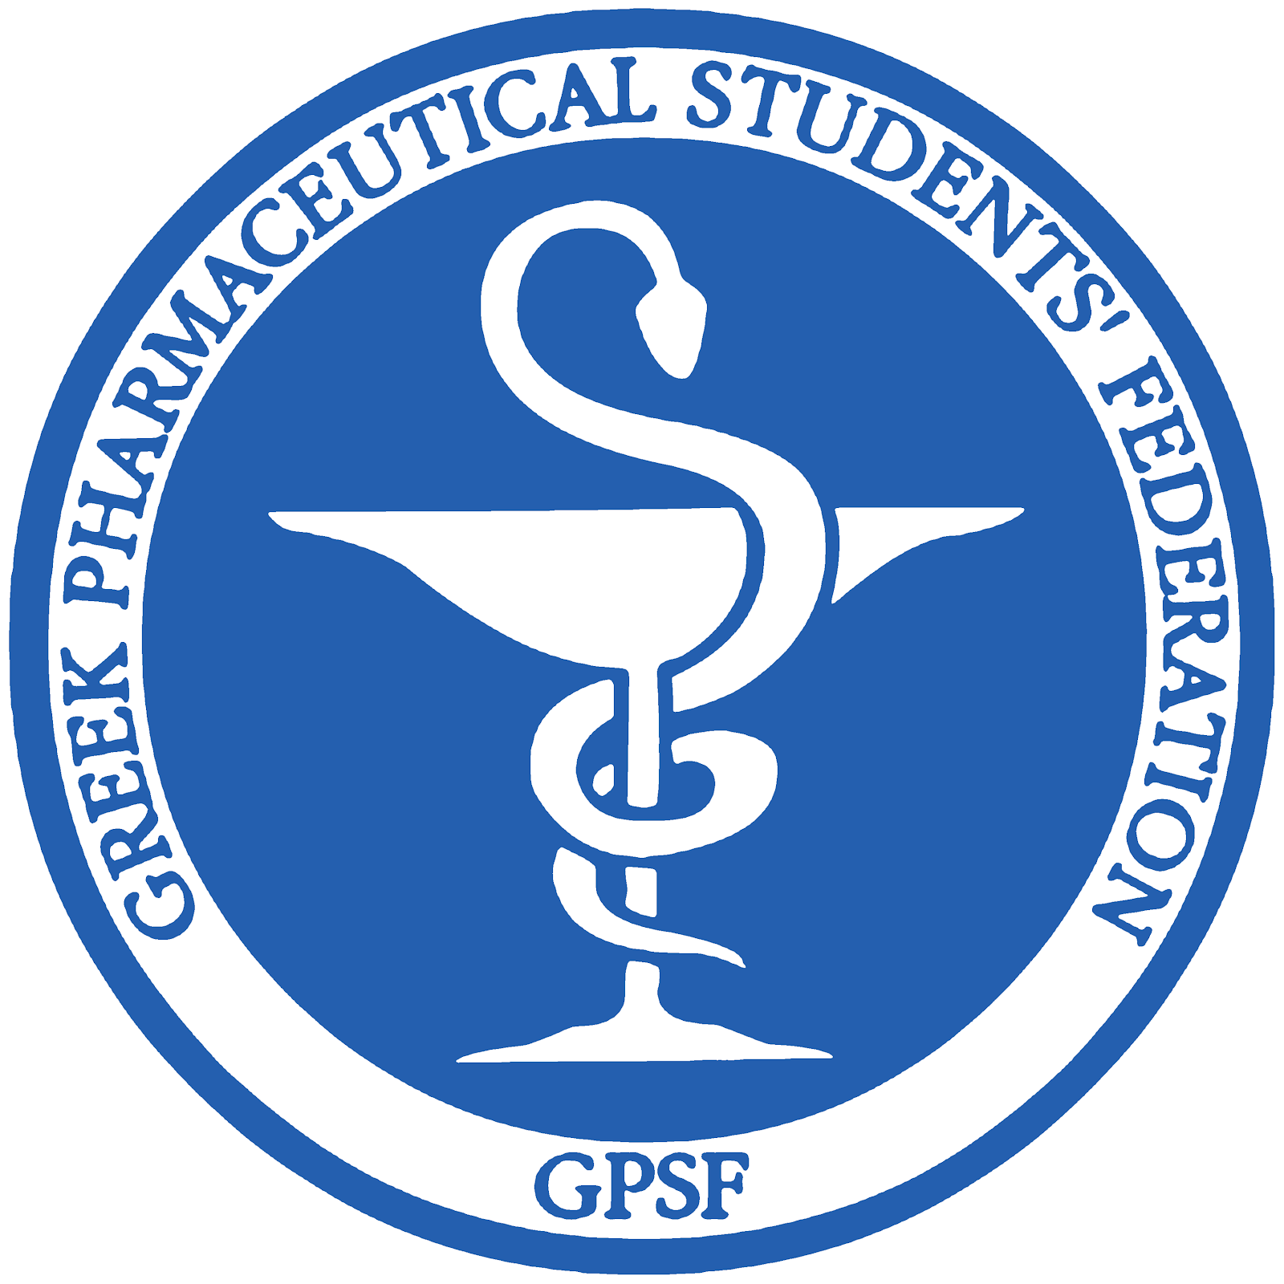  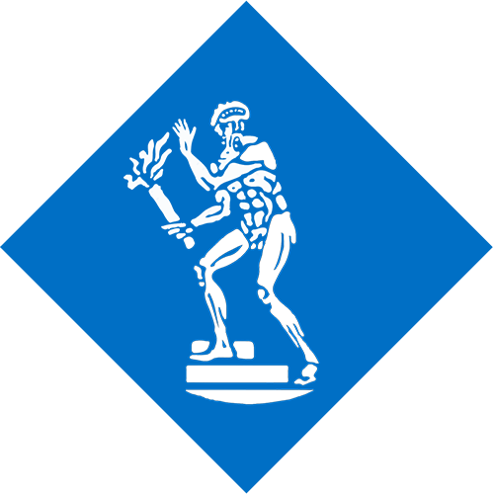

For more information visit our website: <http://24esfie.gr/en/>

You may register for the conference online here: <http://24esfie.gr/en/registration/>

