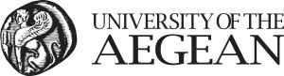
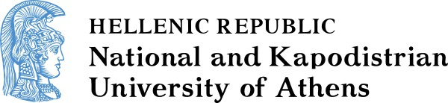

DEPARTMENT OF SOCIOLOGY
SCHOOL OF ECONOMICS AND POLITICAL SCIENCES
DEPARTMENT OF COMMUNICATION AND
MEDIA STUDIES

MSC IN MEDIA & REFUGEE / MIGRATION FLOWS

APPLICATION FORM (ACADEMIC YEAR 2021 - 2022)

FAMILY NAME:  GIVEN NAME:  FATHER’S NAME:  MOTHER’S NAME:  HOME ADRESS:  POSTCODE:  COUNTRY:  PHONE NUMBER (RESIDENCE):  MOBILE NUMBER:  E-MAIL:  Included:  - Photocopy of Identity Card (two sides) or Passport  - Detailed CV (Europass)  - Copy of degree  - Copy of grades transcript  - Proof of English language (level C1)  - Two letters of recommendation  - Copy of thesis or title and a summary or reference that it is not mandatory for the candidate’s first-cycle programme (via mail)  - Academic papers, published either in journals or in the proceedings of international conference proceeding should (via mail)  - Any other relevant information | To the Special Interdepartmental Committee (SIC)  of the MSc "Media and Refugee/ Migration Flows"  Department of Communication and Media Studies  National and Kapodistrian University of Athens  1 Sophocleous Str., 105 59 Athens, 1st floor, Room 104, Department of Postgraduate Studies  Please consider my application for participation in the Interdepartmental Postgraduate Programme  MSc “Media and Refugee / Migration Flows”,  Specialization (1)-News media of refugee flows  Specialization (2)-Communication management of refugee/migration flows  (You can choose both specializations but you will only be considered for one)  The Applicant  ____________________________________  (Date & Place, e.g. Athens, Madrid etc.)  __________________________________  (Signature)
Migromedia.gr
migromedia@media.uoa.gr

FOLLOW US ON SOCIAL MEDIA

